Unit One: Number Sense Name: ___________________

Lesson One: Operations with Integers

Learning Goal – I can add, subtract, multiply and divide integers.

Integer: A number with no fractional part.

Examples : Non-examples :

We must write our answers carefully to keep our work organized and accurate. For example,
Bad form Better form Best form
*two signs in a row *negative numbers in brackets *simplest form possible
6 + – 3 6 + (–3) 6 – 3
–7 x –2 (–7) x (–2) –7(–2)

A. Adding and Subtracting Integers
- Write the expression without brackets.
- 7 + (–2) and 7 – (+2) mean __________
- 7 + (+2) and 7 – (–2) mean __________
- Determine if the answer will be positive or negative.
- Complete the addition or subtraction.

Example 1: Will the answer be positive or negative? Explain why.

a) 7 + 8 = _____ because _______________________________________________________________________________________

b) 6 – 4 = _____ because _______________________________________________________________________________________

c) 7 – 10 = _____ because _______________________________________________________________________________________

d) –6 + 5 = _____ because ______________________________________________________________________________________

e) –6 + 8 = _____ because ______________________________________________________________________________________

f) –6 – 12 = _____ because ______________________________________________________________________________________

Example 2: Write the expression without brackets.

a) 9 + (–3) b) (–7) – (–4) c) (+20) – (+13)

d) (+8) + (+6) e) 3 – (+4) + (–7) f) (–9) – (+2) – (–5) + (–6)
Example 3: Evaluate.

a) –4 + (+1) b) 6 + (–13) c) (+14) – (+9)

d) (–15) + (+15) e) (–3) – (+4) f) (–6) – (–10)

Practice
1. Evaluate.

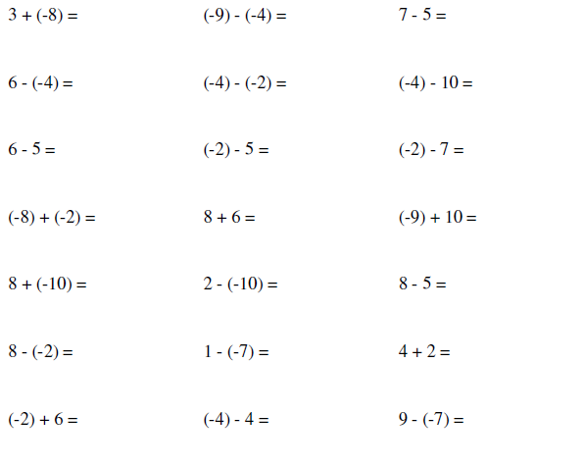
2. Evaluate.

a) –3 + (–2) + 6 b) 7 + (–5) + 5 c) 2 + (–4) + (–3)

d) 15 – 10 – 7 e) 4 – 12 – (–3) f) –5 – (–1) – 9

B. Multiplying and Dividing Integers

When multiplying or dividing two integers of the same sign, the answer is positive.

When multiplying or dividing two integers of a different sign, the answer is negative.

Example 1: Evaluate.

a) 4 × 7 | b) (–5)(9) | c) 10 × (–3) × (–2)
d) 36 ÷ 6 | e) 27 ÷ (–9) | f) (–25) ÷ (–5)

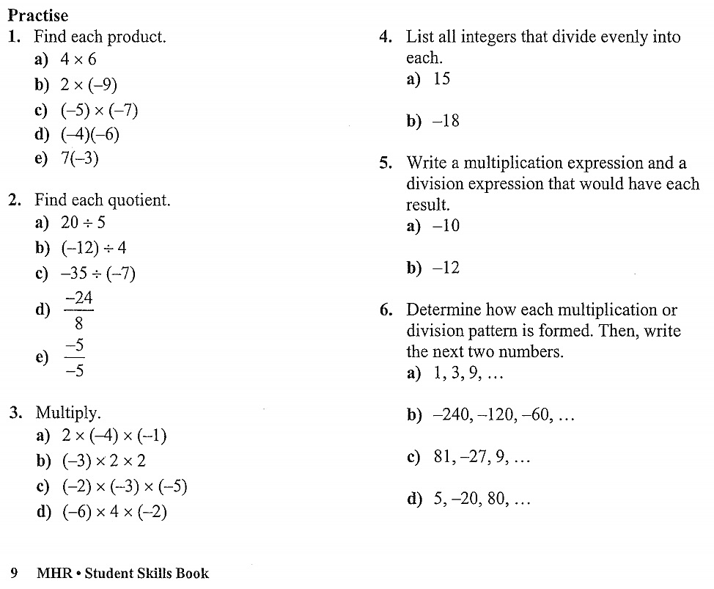

Lesson Two: Order of Operations

Learning Goals – I can use the order of operations to evaluate expressions, including expressions with integers. I understand how to interpret the fraction bar when evaluating expressions.

Mathematical operations must be performed in a standard order.

The mnemonic device BEDMAS is often used to help remember the proper order.
- Brackets
- Exponents
- Division/Multiplication (in the order of left to right)
- Addition/Subtraction (in the order of left to right)

Example 1: Evaluate the expression.

a) 2 + 6 × 4 | b) 4 – 6 ÷ 3 | c) 16 × 4 ÷ 8
d) 2³ + (4 + 2)² | e) (8 – 4) ÷ 4

The fraction bar is a division and a grouping symbol.

Example 2: Evaluate.

a) | $$\frac{6 ×3+2}{5}$$ | b) | $$\frac{42 ÷7}{2}$$ | c) | $$\frac{3+{(15 ÷5)}^{2}}{2-13 ×2}$$

Example 3: Evaluate.

a) 4 – (–3)(2) | b) (6 – 4) – (–2 – 7)
c) –5² + (–3)² | d) $\frac{-48 ÷ 6}{-4 ÷ (-2)}$
e) $\frac{4^{2} - 5{(2)}^{3}}{3 × 2 - 4 × 2^{4}}$ | f) $\frac{3 + 81 ÷ 3^{2}}{\left(4^{3} ÷ 2\right) ÷ 4 - 2}$

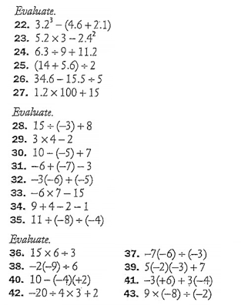
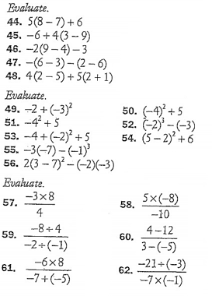
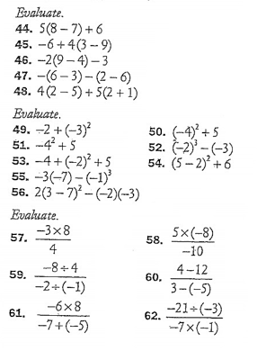
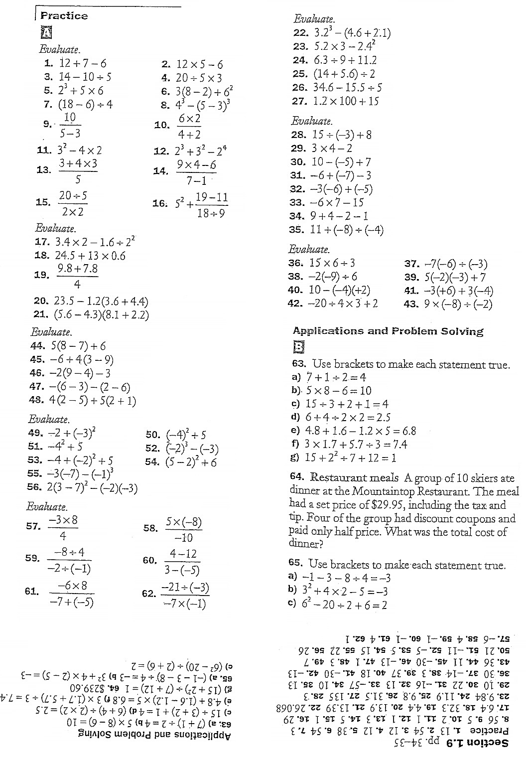
Lesson Three: Expressions with Integers (Substitution)

Learning Goals – I can substitute one or two integers into an expression with a variable and evaluate. I can interpret a word problem by substituting the correct value(s) into an expression and solving.

To evaluate expressions with variables, we can substitute them with integers. Use brackets when substituting.

Example 1: Evaluate for x = −4.

a) $3x+1$ | b) $6-2x$ | c) $x^{2}+2x+7$

Example 2: Evaluate for x = 2 and y = −3.

a) $8x-5y$ | b) $4\left(2x+1\right)-y$ | c) $x^{2}+ y^{2}$

Example 3: Cardi B was standing on the roof of a 144 m tall building. The height of a mic dropped by her from the roof is given by the equation
$$h= -9t^{2}+144$$

where h is the height, in metres above ground, and t is the time, in seconds, since the mic was dropped.

a) What is the height of the mic after 1 s? after 2 s?
b) What is the height of the mic after 4 s? Explain.

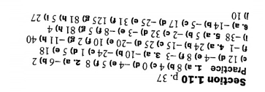
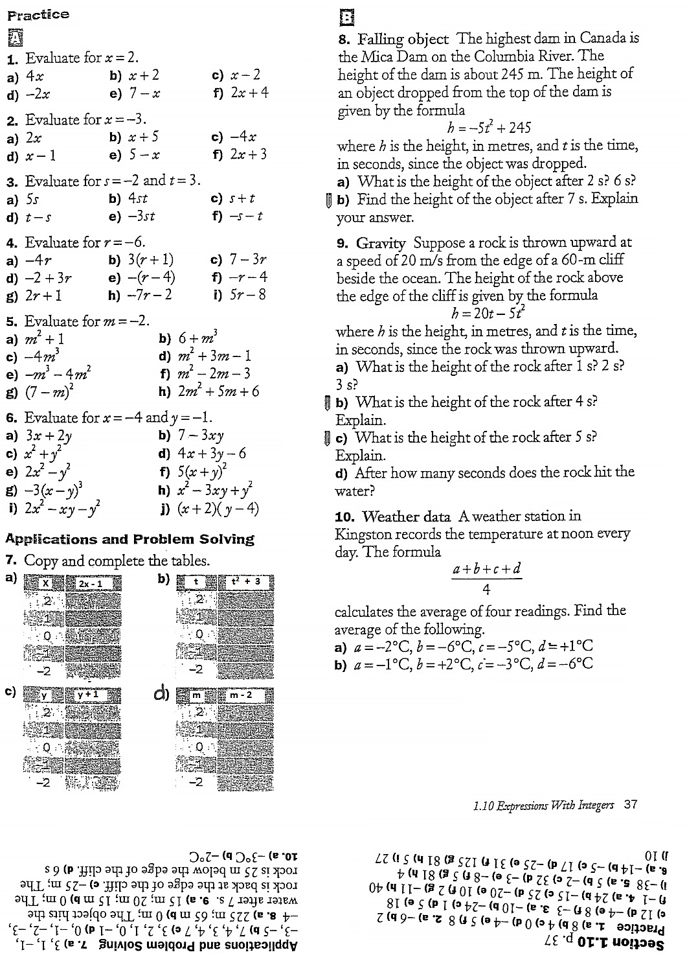
Lesson Four: Review of Fractions

Learning Goal – I can work with fractions with confidence.

A fraction is a part of a whole. Fractions are rational numbers.

$$\frac{numerator}{denominator} \frac{number of equal parts we have}{number of equal parts that the whole is divided into}$$

General Fraction Rules
1. Answers that are fractions must always be reduced to lowest terms.
2. Answers are never given as mixed fractions or decimals unless the question specifically says to do so.
3. Convert mixed fractions to improper fractions first before multiplying, dividing, adding or subtracting.

A. Equivalent Fractions

Multiplying the numerator and denominator by the same number does not change the value of the fraction.

For example,

$\frac{1^{×3}}{2_{×3}}=\frac{3}{6}$ $\frac{4^{×4}}{5_{×4}}=\frac{16}{20}$ $\frac{6^{×2}}{5_{×2}}=\frac{12}{10}$ $\frac{7^{×10}}{9_{×10}}=\frac{70}{90}$

Example 1: Fill in the blanks to find equivalent fractions.

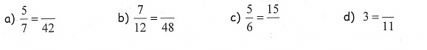
The lowest common denominator is the lowest common multiple of the denominators of two or more fractions.

For example, to find the LCD for $\frac{1}{6}$and $\frac{1}{8}$, list the multiples of 6 and 8 until a common value is reached.

6,

8, $∴$ the LCD for $\frac{1}{6}$and $\frac{1}{8}$ is _______.

Find fractions equivalent to $\frac{1}{6}$and $\frac{1}{8}$ with the lowest common denominator.

$\frac{1}{6}= \frac{ }{}$ $\frac{1}{8}= \frac{ }{}$

Example 2: Use multiples to find the lowest common denominator for each pair of fractions.

a) $\frac{1}{2}, \frac{1}{3}$ b) $\frac{1}{4}, \frac{1}{5}$ c) $\frac{1}{9}, \frac{1}{12}$ d) $\frac{1}{5}, \frac{1}{10}$

Example 3: For each set of fractions, write equivalent fractions with common denominators.

a) $\frac{5}{6}, \frac{2}{9}$ b) $\frac{1}{2}, \frac{3}{4},\frac{1}{6}$
B. Reducing to Lowest Terms

To reduce a fraction, divide the numerator and denominator by the greatest common factor of the numerator and denominator.

For example,

$\frac{{20}^{÷5}}{{35}_{÷5}}=\frac{4}{7}$ $\frac{{18}^{÷6}}{{24}_{÷6}}=\frac{3}{4}$

Example 1: Reduce to lowest terms.

NOTE: Larger numbers may require more steps.

C. Mixed and Improper Fractions

Mixed Fractions: Improper Fractions:

To convert mixed fractions to improper fractions, multiply the whole number with the denominator, add the numerator and put the answer over the denominator.

For example,

The steps are usually done mentally and don’t need to be shown.

Example 1: Convert to an improper fraction.

Practice (A, B and C)
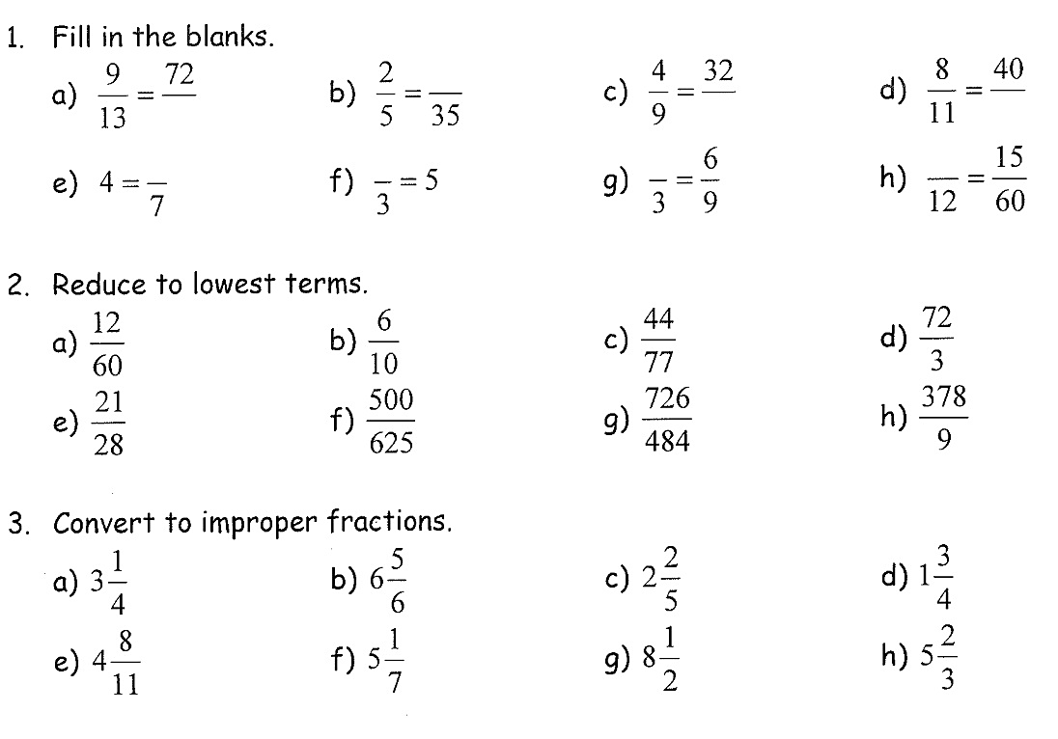
4. Use multiples to find the lowest common denominator for each pair of fractions.

a) $\frac{1}{3}, \frac{1}{4}$ b) $\frac{1}{2}, \frac{1}{5}$ c) $\frac{1}{8}, \frac{1}{9}$ d) $\frac{1}{7}, \frac{1}{14}$

5. For each set of fractions, write equivalent fractions with common denominators.

a) $\frac{1}{2}, \frac{1}{3}$ b) $\frac{1}{3}, \frac{3}{5},\frac{4}{15}$

Answers:
1. a) 104 b) 14 c) 72 d) 55 e) 28 f) 15 g) 2 h) 3
2. a) $\frac{1}{5}$ b) $\frac{3}{5}$ c) $\frac{4}{7}$ d) 24 e) $\frac{3}{4}$ f) $\frac{4}{5}$ g) $\frac{3}{2}$ h) 42
3. a) $\frac{13}{4}$ b) $\frac{41}{6}$ c) $\frac{12}{5}$ d) $\frac{7}{4}$ e) $\frac{52}{11}$ f) $\frac{36}{7}$ g) $\frac{17}{2}$ h) $\frac{17}{3}$
4. a) 12 b) 10 c) 72 d) 14
5. a) $\frac{3}{6}, \frac{2}{6}$ b) $\frac{5}{15}, \frac{9}{15}, \frac{4}{15}$

D. Multiplying Fractions

To multiply fractions that have no common factors, multiply the numerators and multiply the denominators.
For example,

Example 1: Multiply.
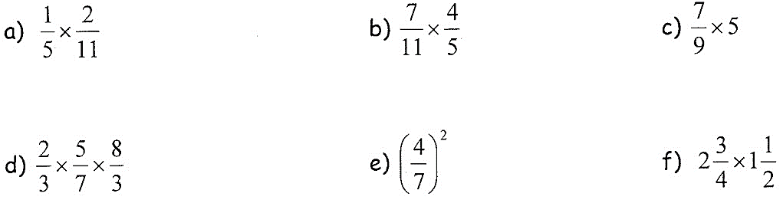

To multiply fractions that have common factors, REDUCE FIRST, then multiply. We can reduce up and down or diagonally. Doing this gives us numbers that are easier to multiply and answers that are already be in lowest terms!

For example,

Example 2: Reduce first, and then multiply.

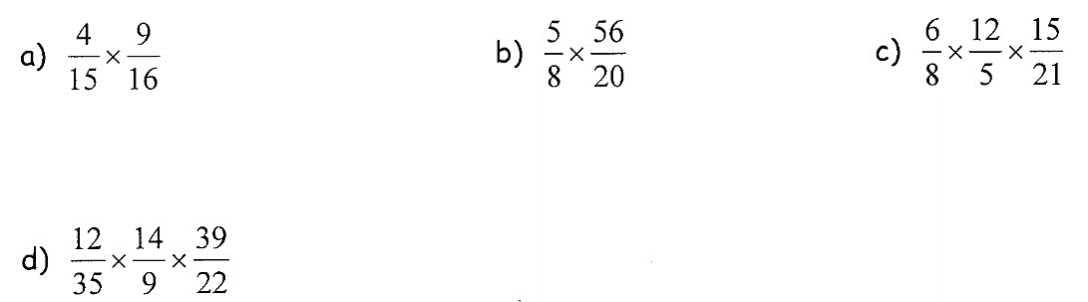

E. Dividing Fractions

Dividing fractions involves taking the reciprocal or inverse of a fraction.

The reciprocal of $\frac{5}{7}$ is The reciprocal of $\frac{1}{2}$ is The reciprocal of 8 is

To divide by a fraction, multiply by the reciprocal. This means:
- Change ÷ to ×
- Take the reciprocal of the fraction AFTER the ÷
- Reduce and multiply

For example,

Example 1: Divide.

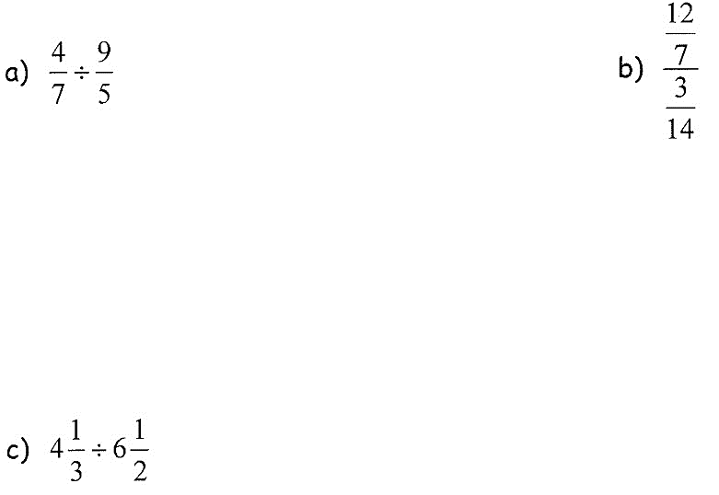

Practice (D and E)
1.

2.

3.
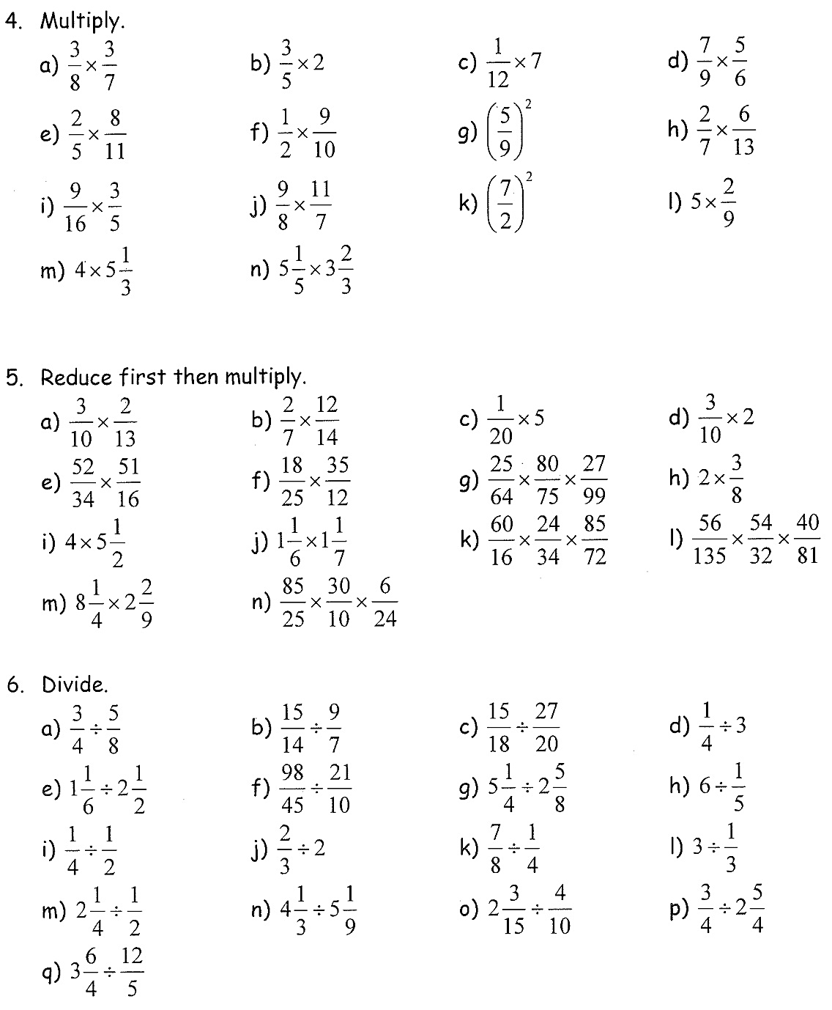
Answers
1

2

3
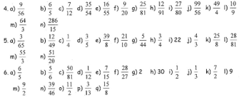

F. Adding and Subtracting Fractions

To add/subtract fractions with the same denominator, add/subtract the numerators over the common denominator.
For example,

To add/subtract fractions with different denominators, first write them as fractions with a common denominator.
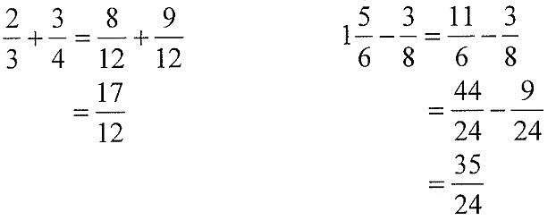
For example,

Example 1: Add or subtract.

d) $-7+\frac{3}{5}$

Practice

1. Add or subtract.

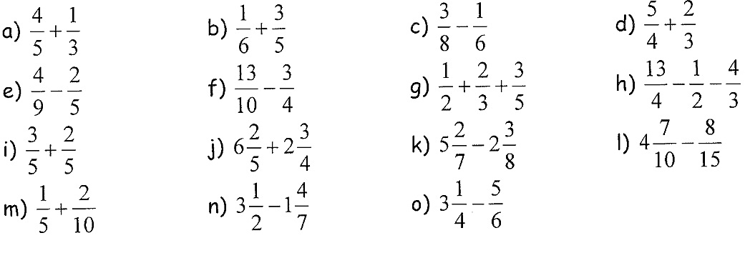

Answers
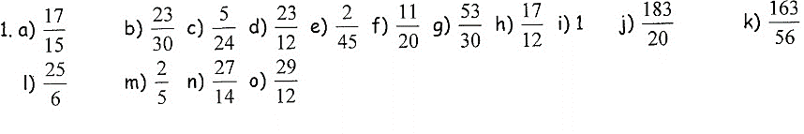

G. Working with Negative Fractions

A negative sign in the denominator can be re-written by putting the negative sign in the numerator. The negative sign “floats” to the top of the fraction. It’s called a “floating negative”.

$$-\frac{6}{5}=\frac{-6}{5}=\frac{6}{-5}=-1\frac{1}{5}$$

To convert negative mixed fractions to improper fractions:
- Ignore the negative sign
- Multiply the whole number with the denominator
- Add the numerator
- Put the answer over the denominator
- Place the negative sign in front of the improper fraction
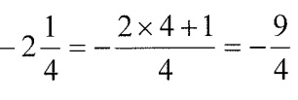
For example,

Example 1: Convert to improper fractions.

Example 2: Multiply or divide. Remember to convert mixed fractions to improper fractions first.

Example 3: Add or subtract.

Practice

1. Multiply or Divide
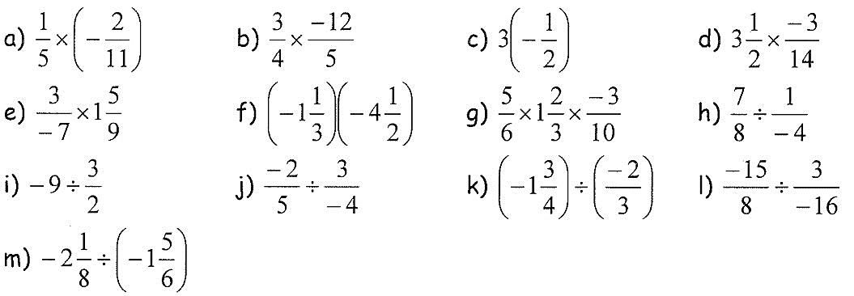

2. Add or subtract.
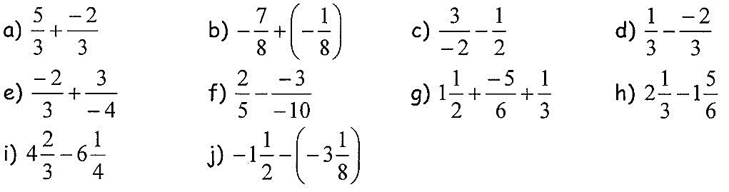
Answers
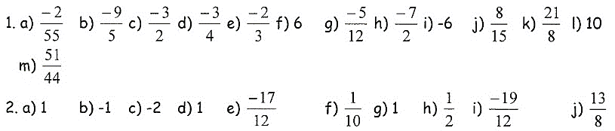

H. Order of Operations with Fractions

Example 1: Evaluate.

a) $\left(\frac{1}{2}+\frac{1}{3}\right)×\frac{2}{5}$ b) $\frac{5}{6}+\frac{2}{3}÷\frac{1}{4}$ c) $1\frac{1}{4}+2\frac{1}{3}÷\frac{1}{6}$

Practice
Evaluate.
a) $\frac{1}{4}×\left(16×3\right)+25÷5$ b) $\frac{800}{500}+\left(-\frac{2}{5}\right)\left(\frac{3}{4}\right)$ c) $2+\left(-\frac{2}{5}\right)÷\left(\frac{8}{15}\right)-\frac{3}{4}$
d) $\frac{7}{5}÷\left(5+\frac{3}{2}\right)$ e) $1+\frac{3}{2}÷\frac{6}{5}$ f) $3\frac{5}{6}×1\frac{5}{6}-1\frac{5}{6}$

Answers
a) 17 b) $\frac{13}{10}$ c) $\frac{1}{2}$ d) $\frac{14}{65}$ e) $\frac{3}{2}$ f) $\frac{121}{36}$
Lesson Five: Review of Percent, Ratio, Rate and Proportion

Learning Goal – I can work with percent, ratio, rate and proportion.

A. Fractions, Decimals and Percentages
Remember how to convert between fractions, decimals and percentages?
Fraction Decimals | Decimal Percent | Percent Fraction
divide the numerator by the denominator | multiply by 100 and add a % sign | write as a fraction over 100 and simplify

Fraction Percent | Percent Decimal | Decimal Fraction
divide the numerator by the denominator, multiply by 100 and add the % sign | divide by 100 and remove the % sign | write as a fraction over 10, 100, etc.  and write in lowest terms

Example 1: Find the following equivalent fraction, decimal and percent.
Fraction | Decimal | Percent
$$\frac{72}{100}=\frac{ }{}$$
$$\frac{3}{4}$$
 | 0.4
 | 0.03
 |  | 50%
 |  | 36%

B. Finding a Percent of a Number

100% means all. Calculate 100% of 80. 50% means half. Calculate 50% of 80.

What does 200 % mean? Calculate 200% of 80.

5% means $\frac{5}{100}$. Calculate 5% of 80. 10% means . Calculate 10% of 80.

Calculate 15% of 200. Calculate 85% of 150.

A pair of jeans is reduced by 25%. The original price was $120. What’s the sale price?

Practice:
1. A sweater is reduced 25% in price in a sale. The original price was $60. Find the sale price.
2. If 40 of 180 cartons of eggs have gone bad, what percentage of the eggs are still good?
3. Sarah has $1000 in the bank. She took out $50 to buy school supplies. What percentage of her savings did she take out?
4. Charlie and his sister Maya are buying a gift for their mom together. If Charlie contributes $15 and Maya contributes $10, what percentage did each sibling contribute?
5. Jack has read 75 pages of a 200-page book. What percentage of the book has he read?
6. Write as a fraction. a) 0.15 b) 80%
7. Write as a decimal. a) $\frac{17}{20}$ b) 34%
8. Write as a percent. a) $\frac{3}{15}$ b) 0.05

Answers:
1. $45, 2. 22%, 3. 5%, 4. Charlie – 60%, Maya – 40%, 5. 37.5%, 6. a) $\frac{3}{20}$, b) $\frac{4}{15}$, 7. a) 0.85, b) 0.34, 8. a) 20%, b) 5%

C. Ratio and Rate

A ratio is a comparison of quantities measured in the same units.
For example, 5 cups of water to 1 cup of lemon juice 1 teacher for 8 students

A ratio can be written in the form 3 : 6 or like a fraction $\frac{3}{6}$. Like fractions, ratios can be reduced. 3 : 6 is equivalent to 1 : 2.

Example 1: Simplify.

a) 20 : 24 b) 21 : 15 c) 10 : 25 : 45

Example 2: A 350 mL can of concentrated frozen OJ is mixed with 1050 mL of water.

a) Write a ratio in simplest form to compare the amount of OJ concentrate to water.

b) Write a ratio in simplest form to compare the amount of concentrate to total juice.

c) How much frozen concentrate is needed to make 1200 mL of juice?

Example 3: If you had 300 Humberside jellybeans (garnet, grey and white) and the ratio of the garnet to grey to white was 5 : 2 : 3.
How many of each colour is there?

A rate compares quantities that are measured in different units.
For example, 100 calories in 2 apples $15 for 4 binders

A unit rate describes how many units of the first type of quantity correspond to 1 unit of the second type of quantity.
For example, kilometres per hour, $km/h$ earnings per week, $\$/week$

Example 1: Calculate the unit rate for each:
a) A car travelled 360 km in 4 hours. b) Liam typed 500 words in 12 minutes.

c) You made $170 in 20 hours.

Practice
1. If 20 eggs cost $5.50, what is the unit price of the eggs?
2. Write the following ratios in simplest form.
a) 18: 10 b) 3: 9: 21
3. It takes a lot of maple sap to make 1L of maple syrup. If 480 L of sap are needed to make 12 L of syrup, how much sap is needed to make 1L of syrup?
4. The ratio of frozen concentrate to water for most juices is 1 : 3. How much water and how much concentrate are needed to make 2 L of juice?
5. Last year the Toronto Maple Leafs had a win to loss ratio of 3:5. This means for every 3 games they won, they lost 5 games. If they played a total of 82 games last season, approximately how many games did they win?
6. Kelly can type 250 words in 5 minutes. John can type 600 words in 10 minutes. Who is faster at typing? By how much?
7. Ms Young drives at 120 km/hr on the highway to get to Kingston for a math conference. If Kingston is 420 km from Milton. How many hours would it take for her to get there?
8. To make a nice pink paint, red and white paint must be mixed in a ratio of 2:5. If you used 8 cups of red paint, how many cups of white paint should you use?

Answers:
1. $0.23/ egg 2. a) 9:5 b) 1: 3: 7
3. 40 L of maple sap 4. 0.5 L of frozen concentrate and 1.5 L of water
5. About 30 games 6. John is faster by 10 words per minute.
7. 3 and a half hours 8. 20 cups of white paint

NUMBER SENSE UNIT REVIEW

UNIT ONE TEST: _____________________________

