**REVIEW: Number Sense Practice Exercises**

**Finding the LCD**

|  |  |
| --- | --- |
|  |  |

**Adding/Subtracting Fractions**

|  |  |
| --- | --- |
|  |  |

**Multiplying/Dividing Fractions**

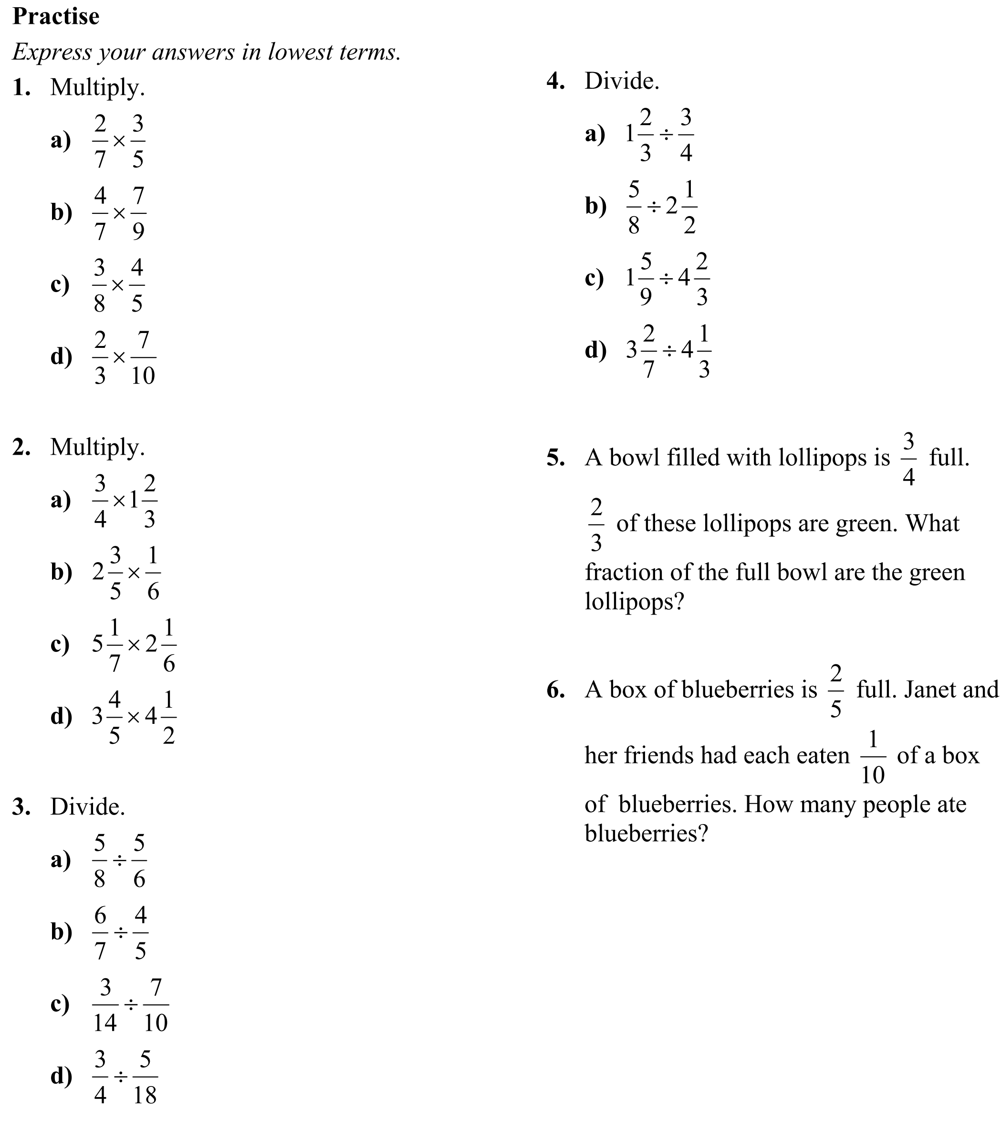

**Answers**

**Finding the LCD:** 1a. 12 b. 10 c. 72; 5a. 6 b. 15

**Adding/Subtracting Fractions:** 6a. b. c.

7. a. h b. h c. h

**Multiplying/Dividing Fractions:** 1a. $\frac{6}{35}$ b. $\frac{4}{9}$ c. $\frac{6}{20}$ d. $\frac{7}{15}$

2.a. $\frac{5}{4}$ b. $\frac{13}{30}$ c. $\frac{78}{7}$ d. $\frac{171}{10}$ 3.a. $\frac{3}{4}$ b. $\frac{15}{14}$ c. $\frac{15}{49}$ d. $\frac{27}{10}$

4.a. $\frac{20}{9}$ b. $\frac{1}{4}$ c. $\frac{1}{3}$ d. $\frac{69}{91}$ 5. $\frac{1}{2}$ filled with green lollipops

6. 4 people

**Answers**

**Adding Integers:** 9.a. 7 b. −6. c. −1 d. −2

10. 5 oC 11. $39

**Subtracting Integers:** 8.a. −1 b. −3 c. −10

d. −2 10. −19 oC 11. −7 oC (it drops 7 degrees because of the wind chill).

**Multiplying/Dividing Integers:** 4.a. 0

b. –7 c. −4 d. 7 5. −48 b. 0 c. 18

**Order of Operations:** 3a. 9 b. 77 c. 20 d. 6

4.a. −4 b. 2 c. 16 d. −8 5.a. 1 b. −2 c. −3

d. 36 8 a. (16 ÷ 4 – 5) × 22 = −4  
b. 16 ÷ 4 – 5 × 22 = −16 (no brackets needed)

9.a. 4 ÷ (2 – 3 ) = −2

b. 20 ÷ (5 – 9) = −5

c. −12 ÷ 3 − −6 = 2

d. (10 – 3) × −2 = −14

|  |  |
| --- | --- |
| **Adding Integers** | **Subtracting Integers** |
| **Multiplying/Dividing Integers** |  |
| **Order of Operations** | |